ASSIGNMENT 1- DAY 2 (KATTA SAI RUTVIK)

1. Create Database command.
create databse InsuranceDB;

2. Create table commands for all the tables with constraints, relationships etc.

Customers

create table customers (
customerid int identity(1,1) primary key,
firstname varchar(50) not null,
lastname varchar(50),
dateofbirth date not null,
phone varchar(15),
email varchar(100) unique
);

Agents
create table agents (
agentid int identity(1,1) primary key,
agentname varchar(100) not null,
city varchar(50),
phone varchar(15),
);
Policies

create table policies (
policyid int identity(1,1) primary key,
policyname varchar(100) not null,
policytype varchar(20),
premiumamount decimal(10,2) not null,
durationyears int not null
);

PolicyAssignments

create table policyassignments (
policyassignmentid int identity(1,1) primary key,
customerid int not null,
policyid int not null,
agentid int not null,
startdate date not null,
enddate date,

constraint fk_pa_customer
foreign key (customerid) references customers(customerid),

constraint fk_pa_policy
foreign key (policyid) references policies(policyid),

constraint fk_pa_agent
foreign key (agentid) references agents(agentid)
);

claims

create table claims (
claimid int identity(1,1) primary key,
policyassignmentid int not null,
claimamount decimal(12,2) not null,
claimdate date not null,
claimstatus varchar(20),

constraint fk_claims_policyassignment
foreign key (policyassignmentid)
references policyassignments(policyassignmentid)
);

3. Insert commands for all tables.

insert into customers (firstname, lastname, dateofbirth, phone, email)
values
('Ravi', 'Kumar', '2003-06-15', '9876543210', 'ravi@gmail.com'),
('Anita', 'Sharma', '2005-09-20', '9876543211', 'anita@gmail.com'),
('Suresh', 'Reddy', '2001-02-10', '9876543212', 'suresh@gmail.com'),
('Priya', 'Mehta', '2010-11-18', '9876543213', 'priya@gmail.com'),
('Amit', 'Verma', '2008-01-05', '9876543214', 'amit@gmail.com');

insert into agents (agentname, city, phone)
values
('Rajesh Rao', 'hyderabad', '9123456780'),
('Sunita Devi', 'bangalore', '9123456781'),
('Mahesh Patel', 'ahmedabad', '9123456782'),
('Anil Kumar', 'chennai', '9123456783'),
('Kavya Nair', 'kochi', '9123456784');

insert into policies (policyname, policytype, premiumamount, durationyears)
values
('Health Secure', 'health', 12000, 1),
('Life Protect', 'life', 25000, 10),
('Motor Safe', 'motor', 8000, 1),
('Health Plus', 'health', 18000, 2),
('Life Smart', 'life', 15000, 1);

insert into policyassignments (customerid, policyid, agentid, startdate, enddate)
values
(1, 1, 1, '2024-01-01', '2025-01-01'),
(2, 2, 2, '2023-06-15', '2033-06-15'),
(3, 3, 3, '2024-03-10', '2025-03-10'),
(4, 4, 1, '2022-11-20', '2024-11-20'),
(5, 5, 4, '2024-05-05', null);

insert into claims (policyassignmentid, claimamount, claimdate, claimstatus)
values
(1, 45000, '2024-06-10', 'approved'),
(1, 12000, '2024-08-15', 'rejected'),
(2, 60000, '2024-01-20', 'approved'),
(3, 30000, '2024-04-05', 'rejected'),
(5, 75000, '2024-09-01', 'approved');

select * from Customers;

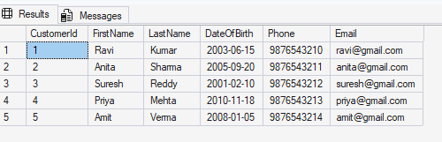

select * from Agents;

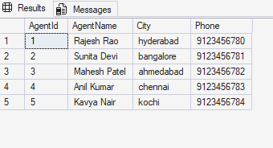

select * from Policies;

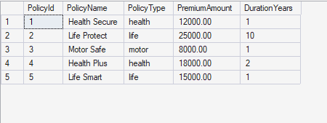

select * from PolicyAssignments;
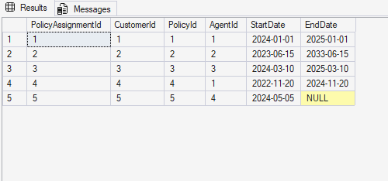

select * from claims;

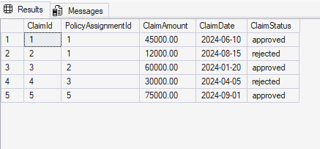

4.2 View all records of PolicyAssignment table with CustomerId, PolicyId, StartDate and
EndDate columns only.

select customerid, policyid, startdate, enddate
from policyassignments;

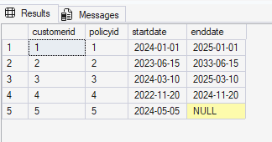

4.3 Display all policies of Health type.

select *
from policies
where policytype = 'health';

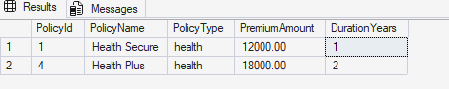

4.4 Display policies having premium amount more than 10000 and DurationYears is 1.

select *
from policies
where premiumamount > 10000
and durationyears = 1;

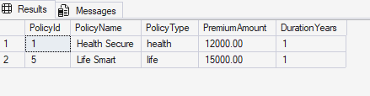

4.5 Display unique city names from where agents belong to.

select distinct city
from Agents;

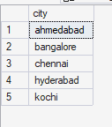

4.6 List policies of type Life, Health, Motor use OR clause.

select *
from policies
where policytype = 'life'
or policytype = 'health'
or policytype = 'motor';

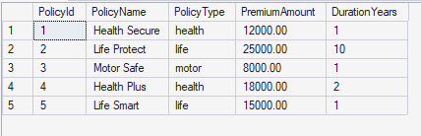

4.7 List policies of type Life, Health, Motor use IN operator.

select *
from policies
where policytype in ('life', 'health', 'motor');

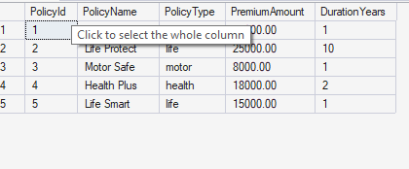

4.8 Display list of customers born after January 1st, 2001 and before December 31st, 2020 using >= and <=

Select *
from customers
where dateofbirth >= '2001-01-01'
and dateofbirth <= '2020-12-31';

4.9 Display list of customers born after January 1st, 2001 and before December 31st, 2020 using between operator

select *
from customers
where dateofbirth between '2001-01-01' and '2020-12-31';

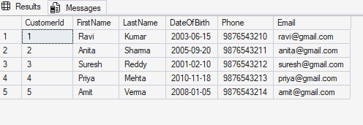

4.10 Display claims data where claim status is Rejected.

select *
from claims
where claimstatus = 'rejected';

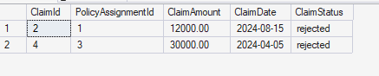

4.11 Display records of Agents who stay in a city whose second letter is 'a'

select *
from agents
where city like '_a%';

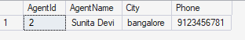

4.12 Display highest and lowest claimamount from claims table

select
max(claimamount) as highest_claimamount,
min(claimamount) as lowest_claimamount
from claims;

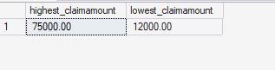

4.13 Display latest claim record

select top 1 *
from claims
order by claimdate desc;

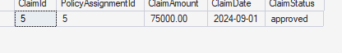

4.14 Increase premium amount to 10% for all health insurance policies

update policies
set premiumamount = premiumamount * 1.10
where policytype = 'health';

select * from policies;

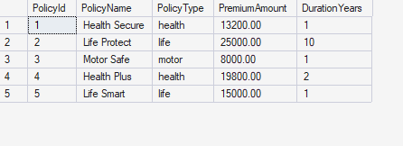

4.15 Delete the record of PolicyAssignments whose EndDate is before today

delete from claims
where policyassignmentid in (
select policyassignmentid
from policyassignments
where enddate < cast(getdate() as date)
);

delete from policyassignments
where enddate < cast(getdate() as date);

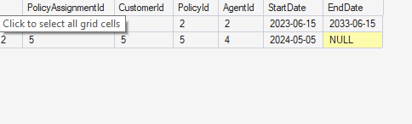

4.16 Display number of claims rejected

select count(*) as rejected_claims_count

from claims

where claimstatus = 'rejected';

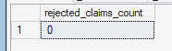

4.17 Display PolicyId, PolicyName, PremiumAmount along with computed fields not in table a
6% LocalTaxes, PremiumAmountWithTax and MonthlyPremiumAmount considering
PremiumAmount is Annual.

select
policyid,
policyname,
premiumamount,
premiumamount * 0.06 as localtaxes,
premiumamount + (premiumamount * 0.06) as premiumamountwithtax,
(premiumamount + (premiumamount * 0.06)) / 12 as monthlypremiumamount
from policies;

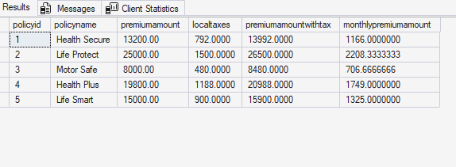

4.18 Write a command to add Address and City columns in the Customers table

alter table customers
add address varchar(200),
city varchar(50);

select * from customers;

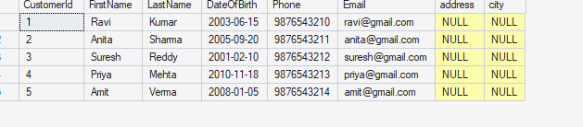

4.19 Write a command to add a new column named DevOfId (DevelopmentOfficerId) in Agents table

alter table agents
add devofid int;

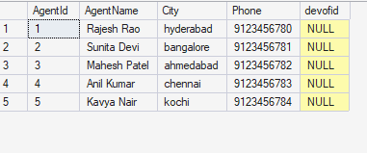

4.20 Write command to make the above DevOfId as a recursive foreign key to AgentId as Parent.

alter table agents
add constraint fk_agents_devofid
foreign key (devofid)
references agents(agentid);

Check, result should be error
update agents
set devofid = 999
where agentid = 3;

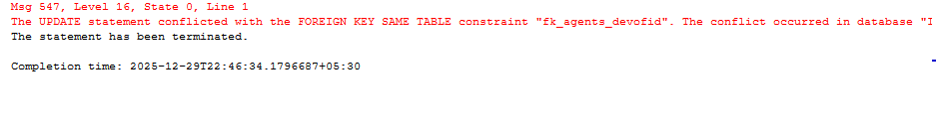

5.1 List all Policies for a CustomerId 5.

select p.policyid, p.policyname, p.policytype, p.premiumamount
from policies p
join policyassignments pa
on p.policyid = pa.policyid
where pa.customerid = 5;

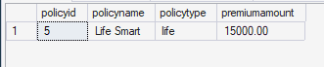

5.2 View all customers with their policies

select

c.customerid,

c.firstname,

c.lastname,

p.policyname,

p.policytype

from customers c

join policyassignments pa

on c.customerid = pa.customerid

join policies p

on pa.policyid = p.policyid;

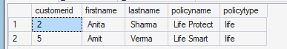

5.3View claims with customer name

select

c.firstname,

c.lastname,

cl.claimid,

cl.claimamount,

cl.claimstatus,

cl.claimdate

from customers c

join policyassignments pa

on c.customerid = pa.customerid

join claims cl

on pa.policyassignmentid = cl.policyassignmentid;

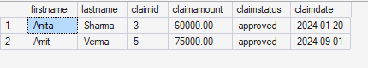

5.4 Display firstname, policyname, agentname, startdate and enddate

select

c.firstname,

p.policyname,

a.agentname,

pa.startdate,

pa.enddate

from customers c

join policyassignments pa

on c.customerid = pa.customerid

join policies p

on pa.policyid = p.policyid

join agents a

on pa.agentid = a.agentid;

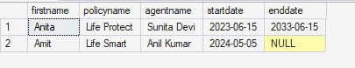

5.5 Display claims report with FirstName, PolicyName, ClaimAmount, ClaimStatus, and ClaimDate from their respective tables.

select
c.firstname,
p.policyname,
cl.claimamount,
cl.claimstatus,
cl.claimdate
from customers c
join policyassignments pa
on c.customerid = pa.customerid
join policies p
on pa.policyid = p.policyid
join claims cl
on pa.policyassignmentid = cl.policyassignmentid;
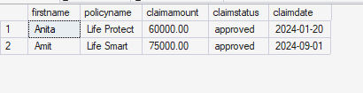

5.6 Display records of Customers with or without Policies

select
c.customerid,
c.firstname,
c.lastname,
p.policyname
from customers c
left join policyassignments pa
on c.customerid = pa.customerid
left join policies p
on pa.policyid = p.policyid;

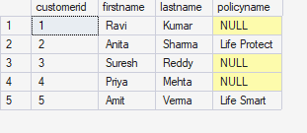
5.7 Display all Customers with NO Claims
select
c.customerid,
c.firstname,
c.lastname
from customers c
left join policyassignments pa
on c.customerid = pa.customerid
left join claims cl
on pa.policyassignmentid = cl.policyassignmentid
where cl.claimid is null;
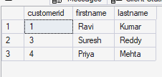

5.8 Show CustomerName with Total Claim Amount per Customer

select
c.customerid,
c.firstname,
sum(cl.claimamount) as total_claim_amount
from customers c
join policyassignments pa
on c.customerid = pa.customerid
join claims cl
on pa.policyassignmentid = cl.policyassignmentid
group by c.customerid, c.firstname;

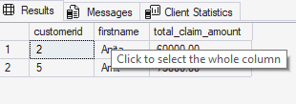

5.9 Show names and total claim amount of customers with claim amount > 50000 (using having)

select
c.customerid,
c.firstname,
sum(cl.claimamount) as total_claim_amount
from customers c
join policyassignments pa
on c.customerid = pa.customerid
join claims cl
on pa.policyassignmentid = cl.policyassignmentid
group by c.customerid, c.firstname
having sum(cl.claimamount) > 50000;

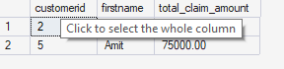

5.10 Display list with Agent-wise Policy Count

select
a.agentid,
a.agentname,
count(pa.policyassignmentid) as policy_count
from agents a
left join policyassignments pa
on a.agentid = pa.agentid
group by a.agentid, a.agentname;

